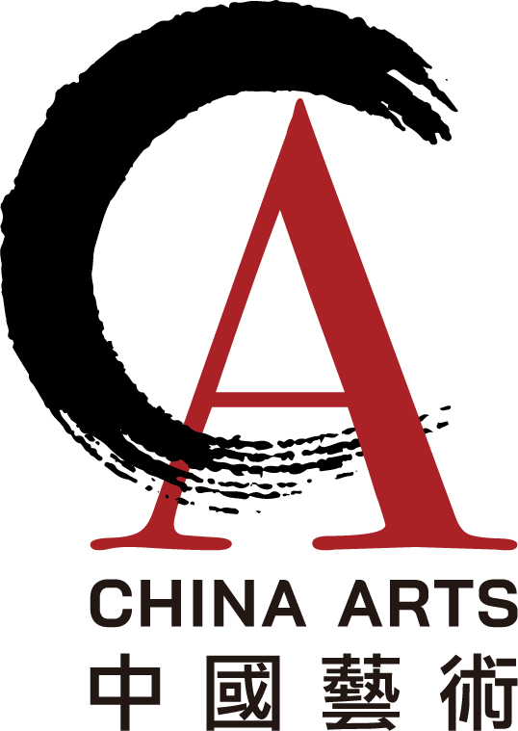 | London International Chinese Music Festival  21 to 27 August 2023  Registration Form | 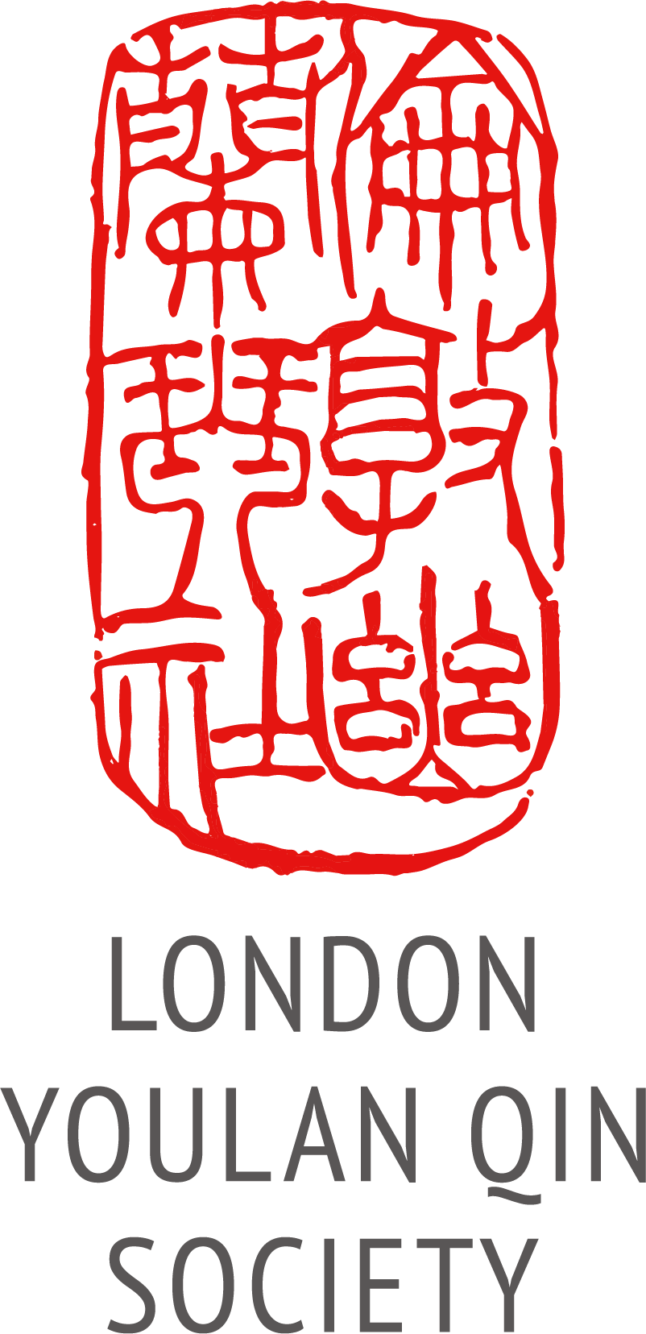
Applicant Details
Title (Dr/Mr/Ms/other):
Name: Age if under 18:
Address:
Phone: Email:
Festival activities
Which instrument do you wish to learn? ………………………………..
Do you already play the instrument? Yes No
If so, to what level? Beginner Intermediate Advanced
Attendees are encouraged to bring their own instrument. Only a limited number are available for hire.
Please tick the box if you need to hire an instrument
Please tick the relevant boxes If you would like to attend the following:
The entire festival (summer school, master classes, talks, guqin conference
and Showcase concert on 26 Aug at SOAS)
Summer school
Guqin conference
Master class by Prof. Li Fengyun (guqin)
Master class by Prof. Wang Jianxin (dizi, xiao and xun)
Cambridge concert, 20 Aug.
London main concert, 22 Aug.
London lunchtime concert, 25 Aug.
Showcase concert, 26 Aug.
Chinese music grading exams
Chinese music competition
Combined grading exam and competition
Contact
Please tick the relevant box, if you would like to:

Join the LYQS mailing list
Become a member of LYQS (This will entitle you to the concessionary rate.)

Payment
Full festival package: summer school (1 instrument), conference, master class, 1 London concert: £495
Summer school only: £390
Conference only: £70
Master classes only: £30 each (non-full package participants)
Instrument hire: Guqin/guzheng/pipa £12 per day All other instruments £6 per day: £ …….
Cambridge concert (Sun 20th): £15 (£12 concessions)
London main concert (Tues 22nd): £20 (£15 concessions)
London lunchtime concert (Tues 25th): Free (tbc)
Showcase concert (Sat 26th, at SOAS): Included in package price for Festival participants;
non-Festival participants: £15 (£12 concessions)
Grading exam: £75 competition: £55 Both: £95

Concessions/LYQS paid-up members £10% discount (except for the grading exams and competition)
LYQS membership: £30, concessions £25 overseas: £20 £ …….
Total: £ …….
I would like to pay by bank transfer. Please pay before 16 August and email a screen capture of the transaction. The Society’s bank details are:
Bank: HSBC
Account name: China Arts Ltd
Account number: 11440691
Sort Code: 40-20-07
IBAN: GB89HBUK40200711440691
BIC: HBUKGB4129V
Reference: [Your surname] [Your initial(s)] LICMF2023
Important: You are responsible for paying any bank charges. If you do not pay them when you register, you will need to pay them in cash on arrival.
If you are unable to do a bank transfer, please contact the secretary to arrange an alternative method of
payment.
Declaration
I declare that the information that I have given is accurate at the time of submission and that I confirm my intention to attend the summer school and be registered as a participant.

Yes

I hereby give consent to the London Youlan Qin Society to use my personal information to contact me with regard to the summer school only, unless I have indicated for them to do so otherwise.

Yes No

Please indicate whether you consent to have your photo/video/media taken during the summer school. These may be used by the LYQS on our website and social media, and in future promotions for our summer schools and other events.

Yes No

If you do not consent, we will do our best to accommodate your request and avoid filming or photographing you. You must also indicate this during your time at the event so that we can identify you and take appropriate measures to avoid inadvertently capturing you on camera.

I wish to register for the Chinese Music Summer School.

Signature: ____________________________ Date: ______________________
Please email the completed form to the secretary at: info@ukchinesemusic.com.
The Festival organisers reserve the right to change or cancel the above programme.

 |  | 