 | London Youlan Qin Society 伦敦幽兰琴社  Chinese guqin and pipa music courses  Tuesdays, 30 April – 9 July, 2019  Registration Form | 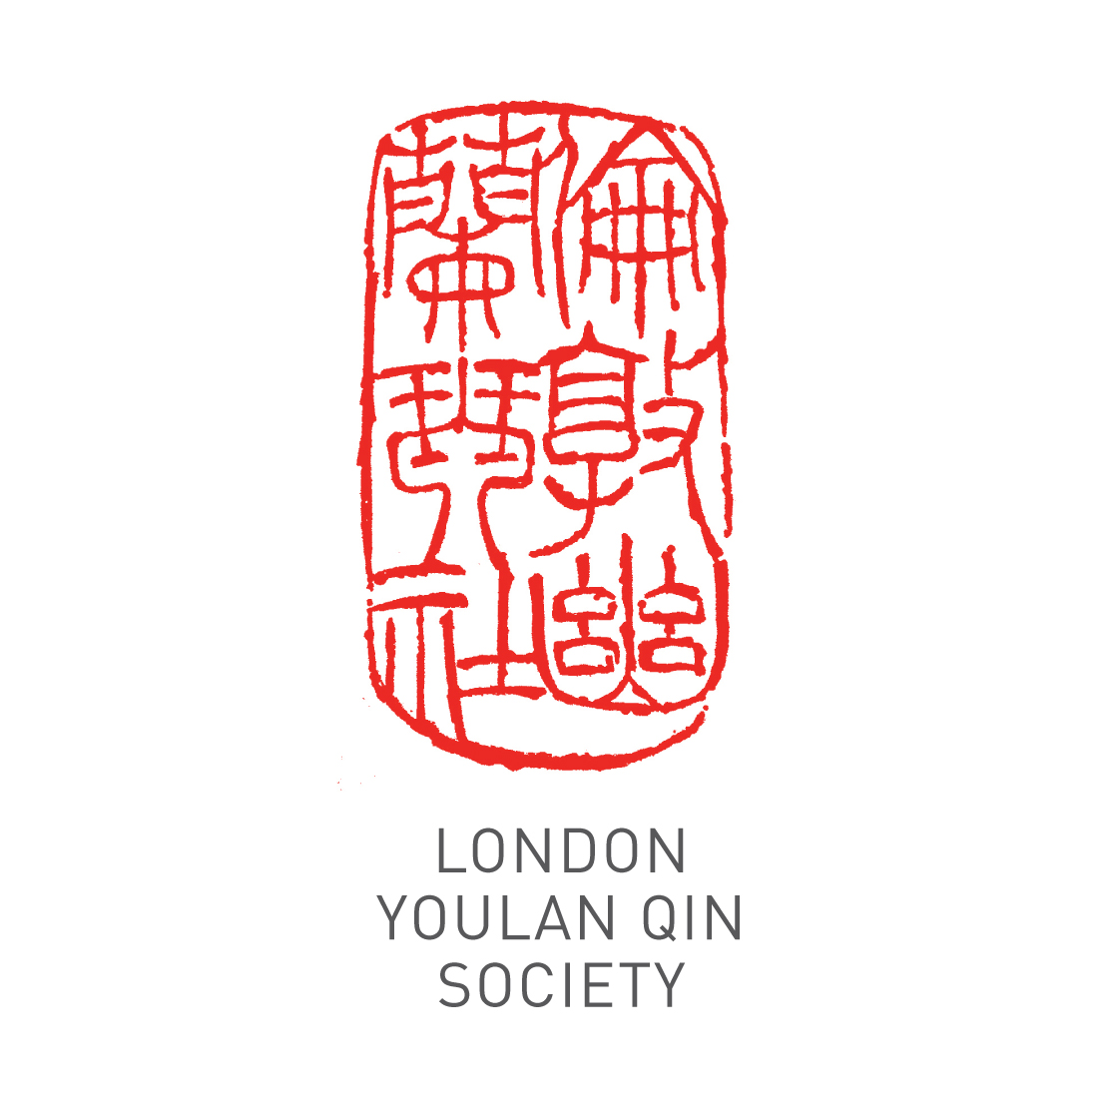
Applicant Details
Title (Dr/Mr/Ms/other):
Name:
Address:
Phone: Email:
Registration Information
Which instrument do you wish to learn? |  | guqin |  | pipa
Do you already play the instrument? |  | Yes |  | No
If so, to what level? | Beginner | Intermediate |  | Advanced
Attendees are encouraged to bring their own instrument. A limited number are available for hire, on a first come first served basis. Please tick the box if you need to hire an instrument

Payment
10 weekly group lessons (£200) £ ……. 10 weekly 1 to 1 or 1 to 2 lessons (£400) £ …….
Time slot: ……………………………
Fees include use of instruments during the classes.
Total £ …….
Account name: China Arts Ltd
Account number: 11440691
Sort Code: 40-20-07
Please pay by bank transfer. Alternatively, make cheques payable to China Arts Ltd and post to Dr Cheng Yu, Guqin and Pipa Courses, London Fo Guang Shan Temple, 84 Margaret St, London W1W 8TD. For bank transfer payments, please specify your name as reference and email a scan of the transaction or bring proof of payment. Please make your payment before 30 April 2019.

I wish to register for the 10 weeks of the course.

Signature: ____________________________ Date: ______________________
Please email the completed form to info@ukchinesemusic.com
Please note that the course fee cannot be refunded if the attendee misses any classes.

